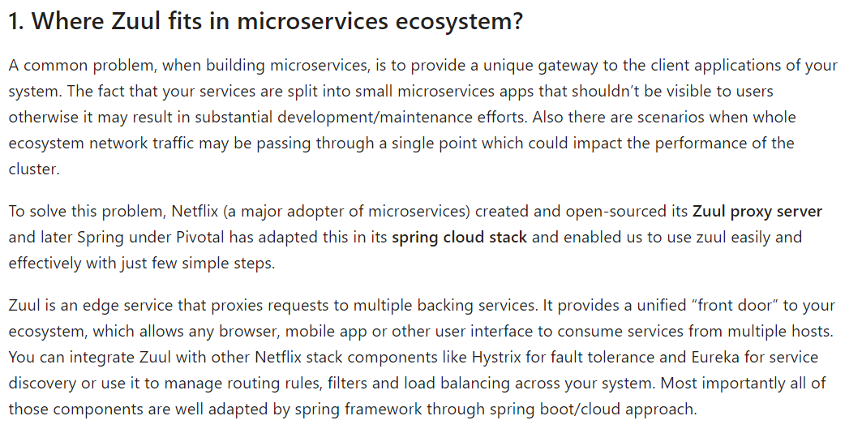  
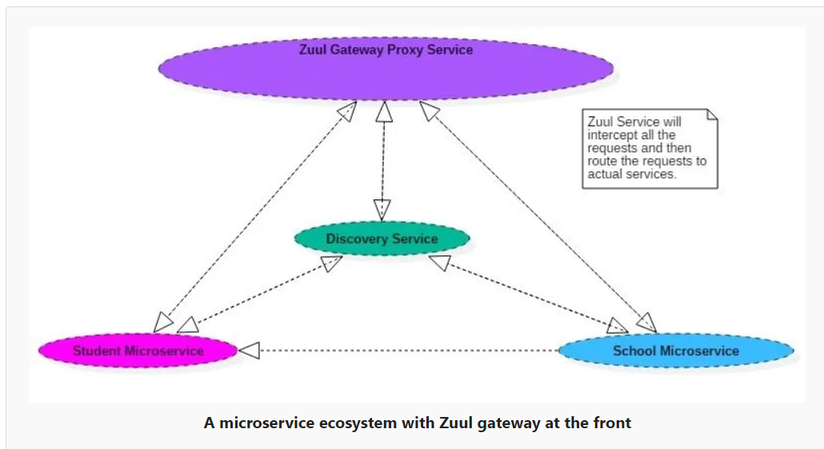  
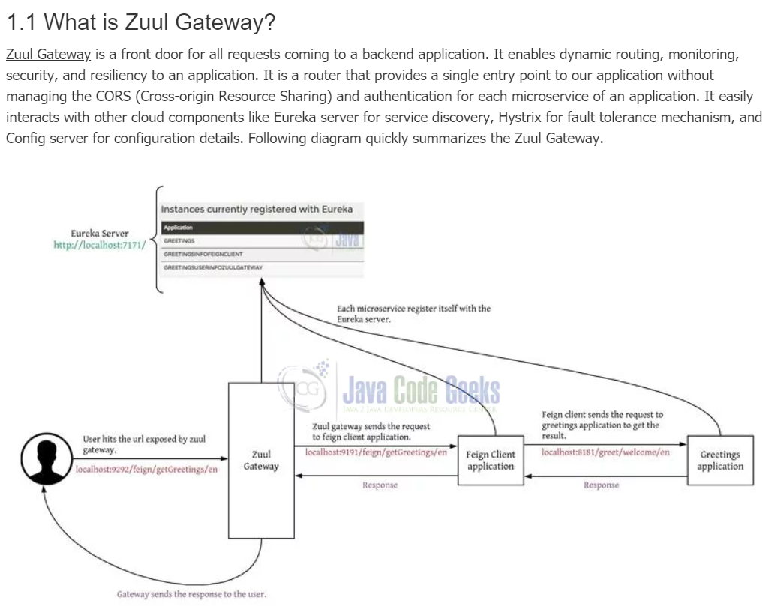  
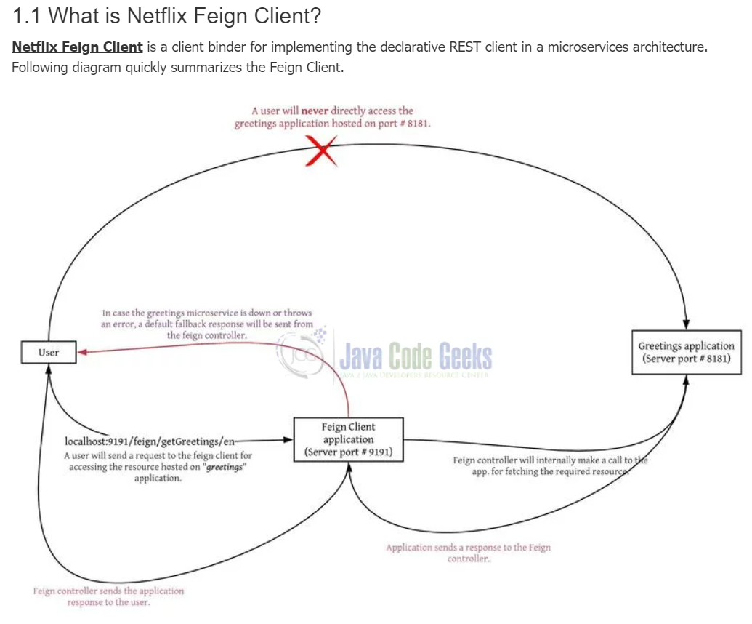  
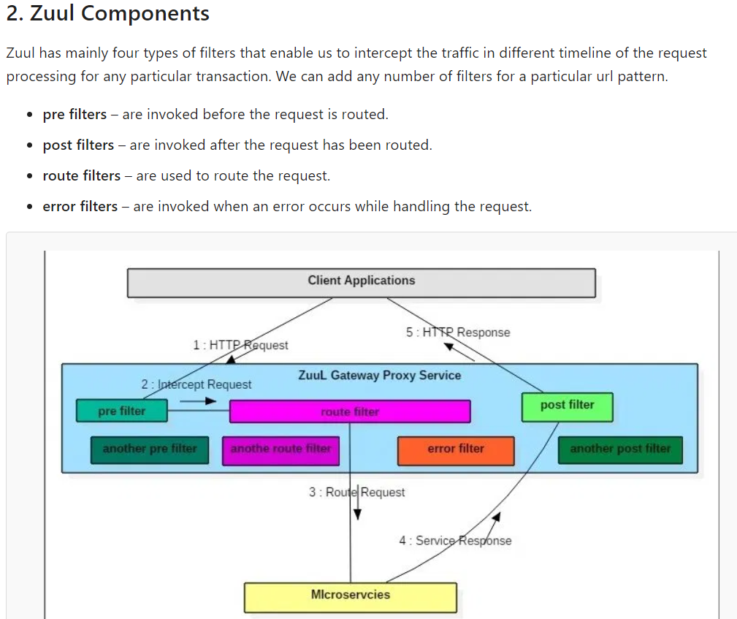

**Eclipse Demo:**  
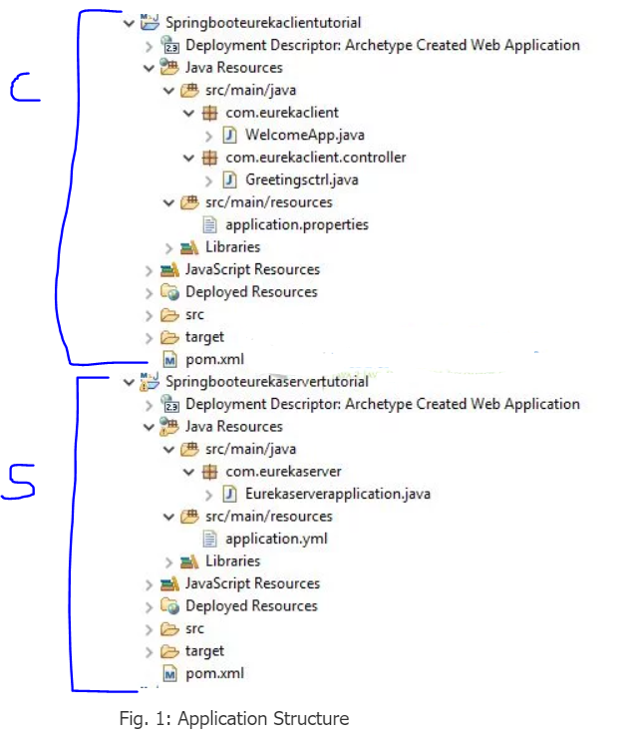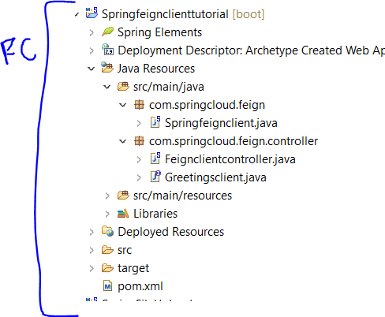 **Here,   
C 🡪** it is acting as client or single micro service  
**S 🡪** it is acting as eureka server  
**FC 🡪** it is acting as the Feign client

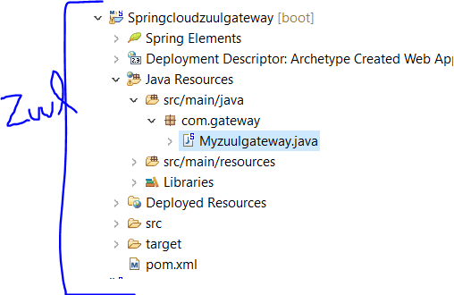

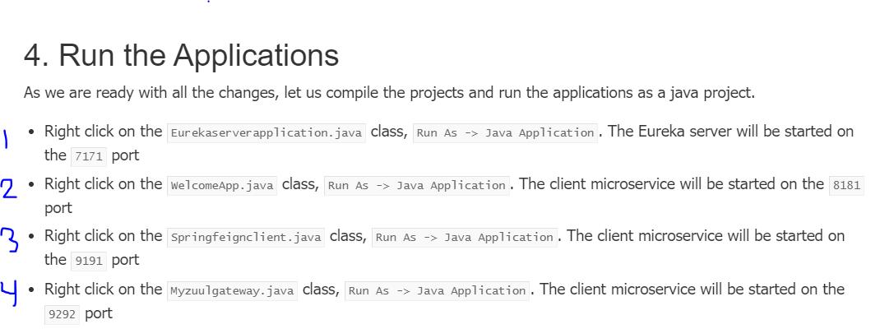  
  
  
**Starting Eureka Server and Client (micro service)**  
1 🡪 Here we are starting the Eureka server 🡪 -🡪 here no instance will be shown  
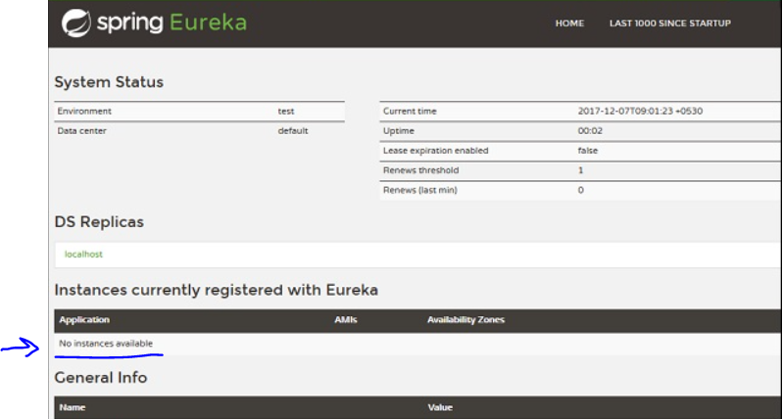  
2 🡪 Here we are starting the Client 🡪 <http://localhost:7171/> -🡪   
 shown below🡪 here that the client micro service is registered with the server under the name   
 – *GREETINGS*  
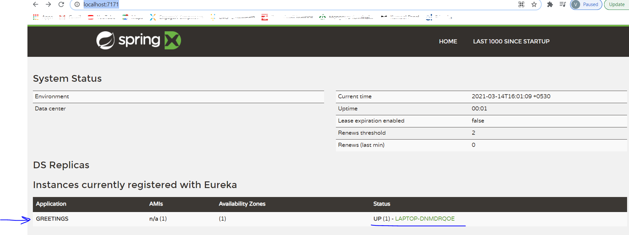

If we want to access eureka client directly on the port number : 8181 then we will go to the controller class to the check the mapping 🡪 Greetingsctrl.java   
en : it is the localeId in the java code

Type the url 🡪 <http://localhost:8181/greet/welcome/en>   
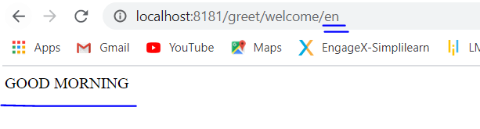

**Starting Netflix Feign Client:**3 🡪 Here we are starting the feign client on the port: 9191.The client microservice will be started on the 9191 port.   
Type the URL 🡪 <http://localhost:9191/feign/getGreetings/en>   
  
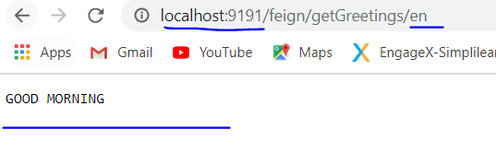

**Starting Zuul Gateway:**4 🡪 Here we are starting the Zuul gateway on the port: 9292. The client microservice will be started on the 9292 port.   
Type the URL 🡪 <http://localhost:9292/feign/getGreetings/en>   
(Here the response is coming from the feign client only but via the zuul gateway 9292 port number)  
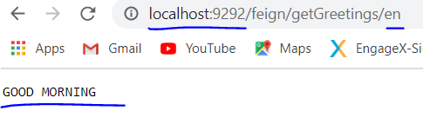

Now open the eureka server again 🡪 <http://localhost:7171/> and all the client services( zuul, feign and greetings application) will be seen registered with the eureka server

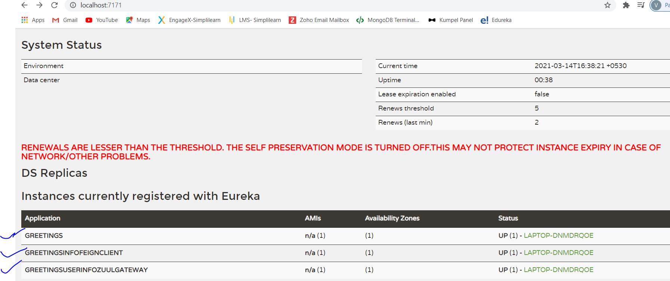

**Where to use this: real scenarios**

**Problem Statement**

Say there was a requirement to forward all the traffic coming to *.adomain.com to adomain.com/*. For Example: a.adomain.com/**/* should be forwarded to adomain.com/a/**/*. Additionally, the proxy gateway should be up all the time and new subdomains need to be registered in the gateway without any downtime. This problem was a very specific one and needed some research to achieve the same.